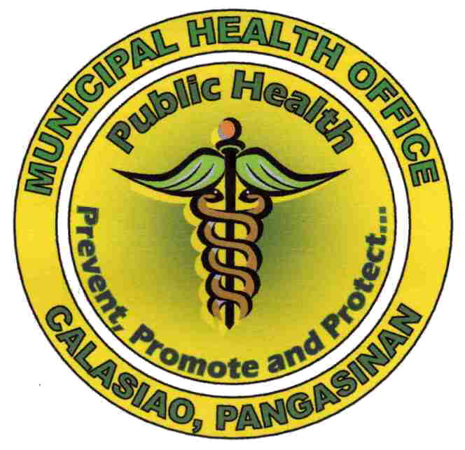
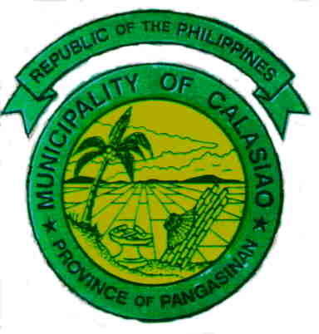
Republic of the Philippines
Province of Pangasinan
Municipality of Calasiao

MUNICIPAL HEALTH OFFICE

BASIC TRAINING FOR
NEW BARANGAY HEALTH WORKERS

- IDENTIFYING INFORMATION:
Project Title: Basic Training for New BHWs
Program Component: Primary Health Care and other Department of Health Programs
Sector: Newly Appointed Barangay Health Workers
Coverage: Municipality of Calasiao
Implementing Agency: Calasiao Municipal Health Office
Funding Source: Calasiao LIGA ng Mga Barangay (24 Barangays of Calasiao, Pangasinan)

- BACKGROUND RATIONALE:
The Barangay Health Workers are community volunteers who are at the forefront of the delivery of health services in their respective barangays. They have been organized and undergone their Basic Training conducted by the Municipal Health Office and other related concerned health agencies, they are recognized and accredited by the Local Health Board and are tasked to assist the local government unit in promoting awareness on health concerns and its effect on the welfare and development of families and community.

However, some BHWs, especially the new ones, have not been given their BHW Basic Training. The Basic Training is a requirement for the accreditation of their BHW membership by the Local Health Board. They must have the knowledge, the positive attitude and the necessary skills to undertake their assigned activities in their barangays. The Basic Training will empower the BHWs to perform their three major roles in the community: as a Community Organizer, a Health Educator and a Health Service Provider.

- GOAL
The goal of this training is to provide the new BHWs the necessary knowledge, acquire positive attitude and improve interpersonal community skills to become effective information providers and advocates of health program, projects and activities.

- CONTENT
Topics for Discussion:
- Roles and Function of BHWs
- DOH and LGU Priority Health Thrusts
- Care for Acute Respiratory Infections (CARI)
- Control of Diarrheal Diseases
- Safe Motherhood and Family Planning
- Pre-Natal Care\
- Post-Partum Care
- Breast Feeding
- Expanded Program for Immunization (EPI)
- Family Planning
- Child Growth and Development Monitoring
- Nutrition for Children
- Common Infectious Diseases
- Basic Facts About Tuberculosis
- Primers on Dengue Fever, Typhoid Fever and Leptospirosis

- METHODOLOGIES:
- Lecture/discussion
- Demolition/Return Demonstration /Practicum
- Small Group Workshop

- REQUIREMENT:
- Active Participation
- Punctuality and Attendance

- STAFF/PARTICIPANTS
- Participants are BHWs who are:
- Newly appointed but not accredited BHWs
- BHWs still without Basic Training (if their PBs will allow them and shoulder their training fee)
- Actively participating in community health activities
- Municipal Health Office Staff and other resource persons (from CHD and PHO)

- OPERATING DETAILS:
- Duration: 2 days per Batch
Date: August 3-4, 2011 First Batch
August 10-11, 2011 Second Batch
Venue: Third Floor, Calasiao Municipal Building
No. of Batches: 2
- Training materials: LCD projector, laptop computer, envelope, manila paper/newsprint, cartolina,. pentel pen, ballpen, paper, white board, white board markers, pictures,

S E S S I O N P L A N
TIME |  | DAY 1 | DAY 2
8:00- 8:30 | A.M. | Arrival/Registration  Opening Program | Arrival/Registration
8:30 – 9:00 |  | Leveling of Expectations and Overview of the Training –  Mr. Robert Padilla | Roles and Functions of BHWs – Dr. Jesus Arturo P. de Vera
9:00-10:00 |  | Control of Diarrheal Diseases, etc.–  Dr. Jesus Arturo P. de Vera | Basic Facts About Tuberculosis– Mrs. Milrose U. Caburain
10:00- 10:15 |  | A.M. Snacks | A.M. Snacks
10:15- 11:00 |  | Pre-Natal Care –  Dr. Cristina P. Estrada | Child Growth and Development Monitoring– Mr. Robert Padilla
11:00- 12:00 |  | Plenary Discussion | Plenary Discussion
12:00- 1:30 |  | Lunch Break | Lunch Break
!:30- 2:15 | P.M. | Post-Partum Care –  Mrs. Lolita A. Quinto | Family Planning –  Mrs. Regilina P. David
2:15 – 3:00 |  | Breast Feeding –  Mrs. Regilina P. David | Nutrition for Children–  Mrs. Lolita A. Quinto
3:00-3:15 |  | P. M. Snacks | P. M. Snacks
3:15 – 4:00 |  | Care for Acute Respiratory  Infections –  Mrs. Milrose U. Caburain | Expanded Program for Immunization –  Dr. Cristina P. Estrada
4:00 - 5:00 |  | Plenary Discussion | Plenary Discussion

- BUDGET REQUIREMENT

 | No. of BHWs Trainees | 116
 | Training Fee per BHW | 1,500.00
 | TOTAL AMOUNT= | P 174,000.00
Total No. of Participants: | 58 | per batch
Total No. of Facilitators: | 14
Total No. of Trainors: | 6
 | 78
Budget for lunch and 2 snacks | 300.00 | /participant per day
x | 78 | participants
 | 23,400.00
Trainors honorarium: | 1,500.00
x | 6 | trainors
 | 9,000.00
Subtotal per day | P 32,400.00
 | 4 | Days (2 Batches)
 | P 129,600.00
Training Materials | 344.00 | /participant
x | 112 | participants
 | P 38,528.00
Secretariat Expenses | 5,000.00
Miscellaneous | 872.00
 | TOTAL AMOUNT= | P 174,000.00

 | Training Materials:
 |  | 1. Certificates | 30.00 |  | Xerox:
 |  | 2. Pen | 30.00 |  | 10 | pages
 |  | 3. Pencil | 14.00 |  | 10 | Topics
 |  | 4. Plastic Envelope | 45.00 |  | 100 | pages/participant
 |  | 5. Xerox Notes | 225.00 |  | 2.25 | xerox per page
 |  |  | 344.00 |  | 225.00

- LEGITIMIZATION

A certificate of training will be issued to all who successfully comply with training requirements and their names will be submitted for accreditation to the Local Health Board which will endorse the names of the accredited BHWs to the Office of the Municipal Mayor, Municipal Budget Office, Municipal Accounting Office and the Municipal Treasurer’s Office.
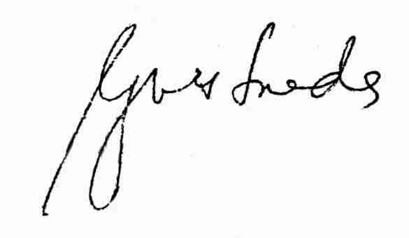

Prepared by:

DR. JESUS ARTURO P. DE VERA DR. CRISTINA P. ESTRADA
Municipal Health Officer Rural Health Physician

