

**MUNICIPAL HEALTH OFFICE**

**Calasiao, Pangasinan**

**HEALTH ADVISORY ON**

**INFLUENZA A (H1N1)**



**WHAT IS INFLUENZA A(H1N1)?**

* Influenza A(H1N1) is caused by a novel virus that resulted from the

reassortment of 4 viruses from pigs, human and birds.

* It is a new virus causing illness to people.
* It was first detected in people in April 2009 in the United States.
* This virus is spreading from person-to-person, probably in much the same

way that regular seasonal influenza viruses spread.

* There is no vaccine yet to protect humans from this virus.
* There are existing and recommended medicines that are effective in treating these Influenza A(H1N1)
* Influenza A (H1N1) can be fatal to humans due to severe respiratory distress

(pneumonia)

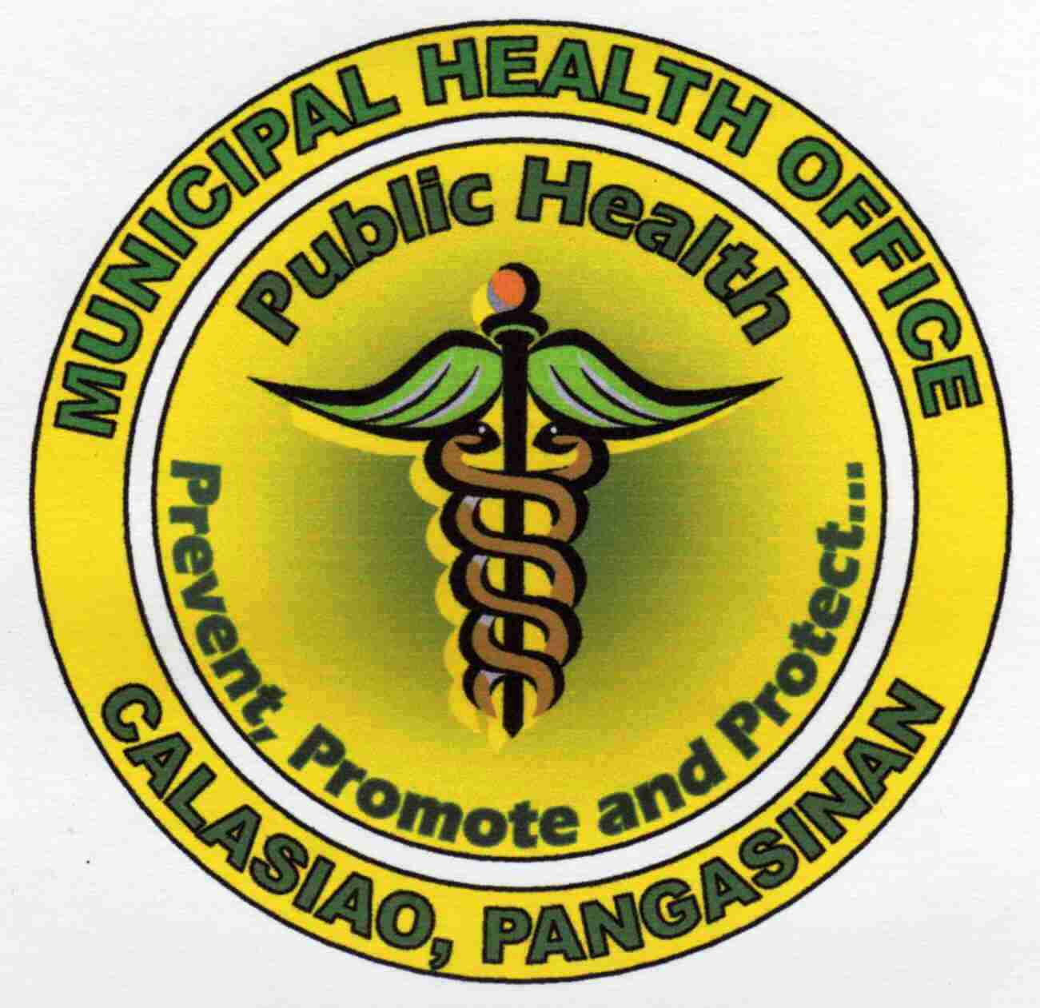

**SIGNS AND SYMPTOMS IN HUMANS**

* Similar to the symptoms of regular flu such as:
  + - Fever
    - Headache
    - Fatigue
    - Muscle or joint pains
    - Lack of appetite
    - Runny nose
    - Sore throat
    - Cough
    - Some cases have reported having diarrhea, vomiting and nausea

**MODE OF TRANSMISSION**

* Direct exposure to cough and sneeze of the infected person
* Touching mouth, nose or eyes after touching infected things

*Influenza A (H1N1) is not transmitted by eating properly handled thoroughly cooked pork.*

**PREVENTION**

* Cover nose and mouth when coughing and sneezing
* Always wash hands with soap and water
* Use alcohol-based hand sanitizers
* Avoid close contact with sick people
* Increase body’s resistance
* have at least 8 hours of sleep
* be physically active
* manage stress
* drink plenty of fluids
* eat nutritious foods

**BE VIGILANT!**

**If you have any of the above signs and symptoms,**

**immediately consult your health worker**.

Calasiao Municipal Health Office: Rural Health Unit – I 517-2234

Rural Health Unit – II 517-2410