BASIC TRAINING FOR BARANGAY HEALTH WORKERS
Calasiao, Pangasinan

GROWTH MONITORING AND PROMOTION

The first 5 years of life is very vulnerable and important. This period will be the basis of the child’s future physical, intellectual, social and emotional, well being.
You have been helping or will be helping the midwives in the growth monitoring of children under 5 years old. This module will help you positively contribute to the growth and development of the children in your community.

A. GROWTH MONITORING AND PROMOTION
Growth promotion refers to a group of activities that support and maintain the proper physical, mental and social development of children. It begins from the time of conception in the mother’s womb.

Growth monitoring is an integral part of the growth promotion. It is a process of periodic assessment of the physical, mental, and social changes in a child. It detects early growth failure which can be result of illness, wrong practice or very often a combination of these factors.
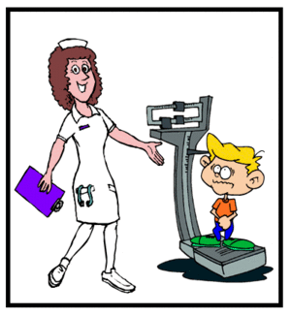
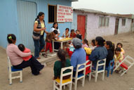

What is the meaning of “growth”?

From the moment parents greet their newborn, they watch the baby's progress eagerly, anticipating every inch of growth and each new developmental milestone along the way. However, growth is not only getting physically bigger and taller but also growing and developing mentally, socially, and emotionally.

B. BASIC COMPONENTS OF PROMOTION
The 5 Basic Components of Growth Promotion of a Child:
1. Proper nutrition and health of pregnant women;
2. Promotion of exclusive breastfeeding and proper complementary feeding of infants;
3. Immunizations and prevention, treatment and control of infections especially measles, diarrhea and tuberculosis;
4. Environmental protection and cleanliness, including personal hygiene, provision of safe water and use of sanitary disposal; and
5. Prevention of smoking, alcohol drinking and promotion of healthy lifestyle.

It is also very important to touch, talk, sing and interact with the child. Provide him/her with safe and colorful things he/she can touch. This way, the child will be mentally stimulated.

A woman during pregnancy should have proper nutrition
and health protection. Her health is vital to her and to her baby.

C. DIFFERENCE BETWEEN GROWTH MONITORING AND
“OPERATION TIMBANG”
Operation Timbang differs from growth monitoring as it is only done once a year. Its objective is to determine the nutritional status of 0-83 month old children in the community and identify those who are underweight.

On the other hand, growth monitoring is not only regular weighing but also periodic assessment of the physical, mental and emotional changes of children under 5 years of age.

How to measure Standing Height:
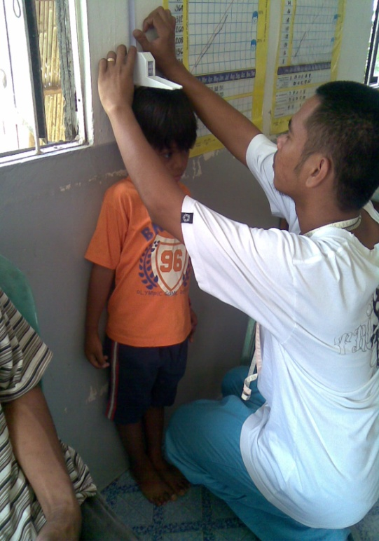
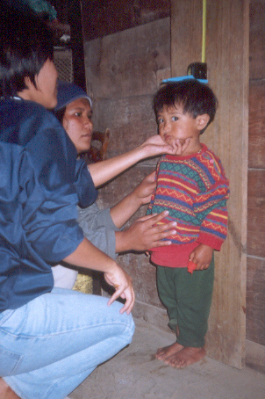
Instruct the subject child to stand barefoot and straight, with back, heels, buttocks, and shoulder blades in contact with the wall. As much as possible, ask the child to stand tall to straighten the spine.

Let the child stand relaxed directly below the head-bar with head positioned such that the Frankfurter plane is horizontal, feet together, knees straight, and arms hanging loosely at the sides with palm facing the thighs. For younger subjects, hold the heels to ensure that they remain on the ground.

Gently lower the head-bar until it touches the crown of the head and compresses the hair.
Take reading at eye level with the head-bar and record the number found at the top of the red line indicator window. Height measurement should be recorded to the last completed 0.1 cm.

- If a child is less than 2 years old, will not lie down for measurement of length, measure standing height and add 0.7 cm to convert to length.
- If a child is aged 2 years or older and cannot stand, measure recumbent length and subtract 0.7cm to convert to height.

In general, standing height is about 0.7cm. less than recumbent length.

Parts of the Infantometer

How to measure Recumbent Length:
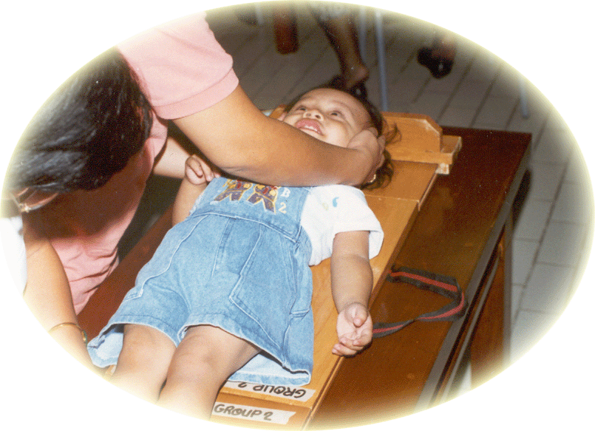
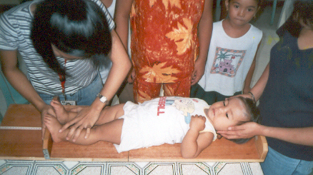

D. THE GROWTH MONITORING CHART
The advantages of using the growth monitoring chart are the ff:
- It can monitor the growth of the child;
- It shows the prompt and earliest detection of deviation from normal pattern of growth;
- It is a basis for teaching the mother how to feed the child;
- It is a guide for evaluating the factors which influence the child’s health and nutrition; and
- It serves as a record of immunization schedule.

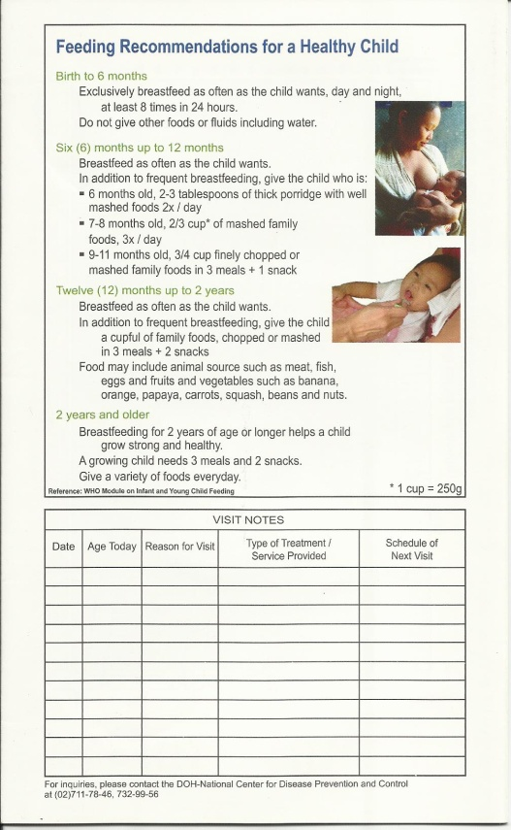
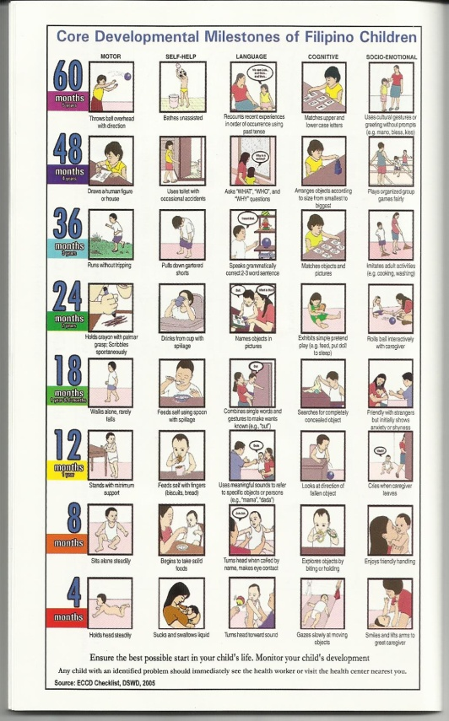
Early Childhood Care and Development (ECCD) Chart
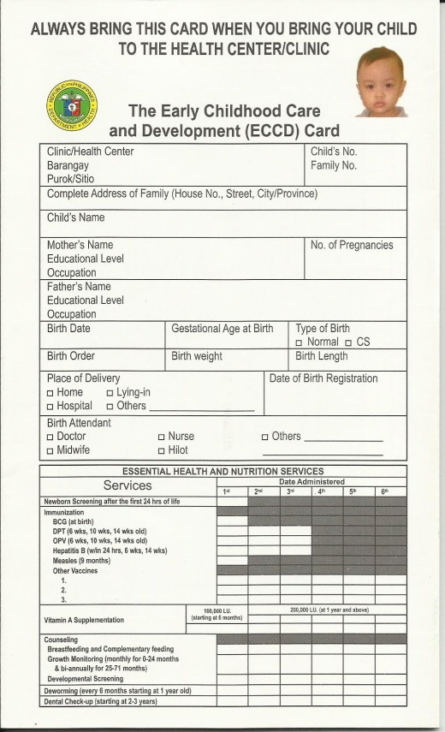

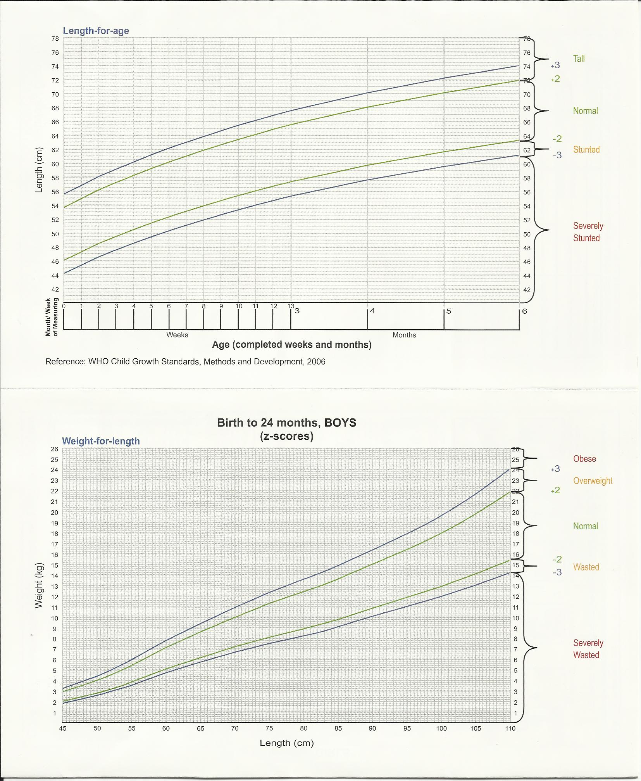

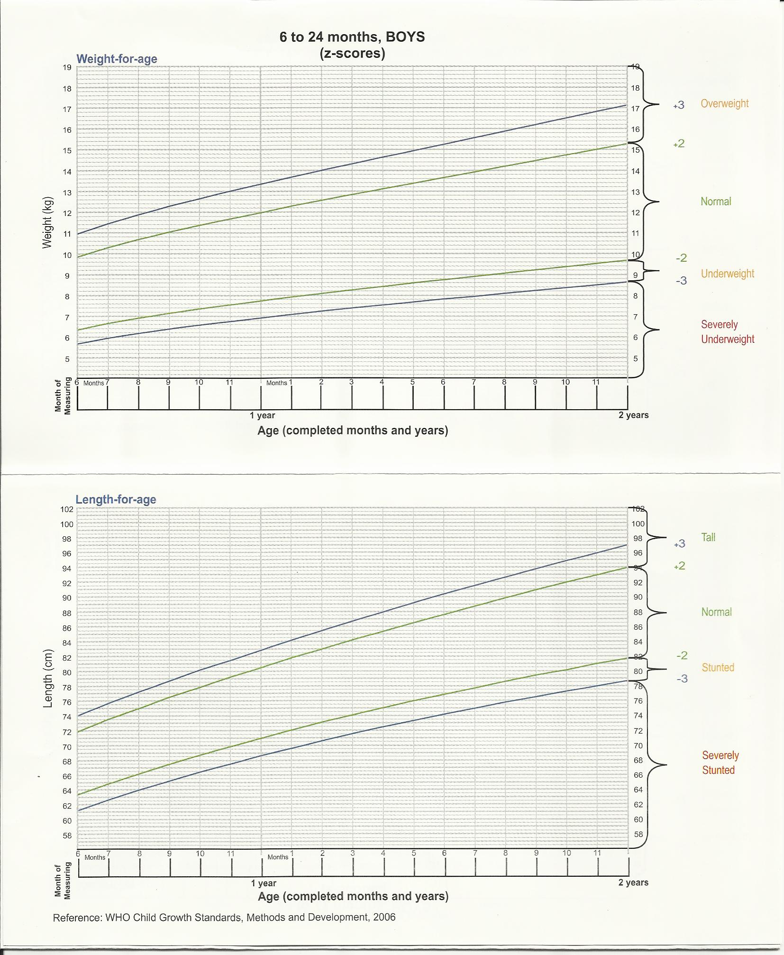

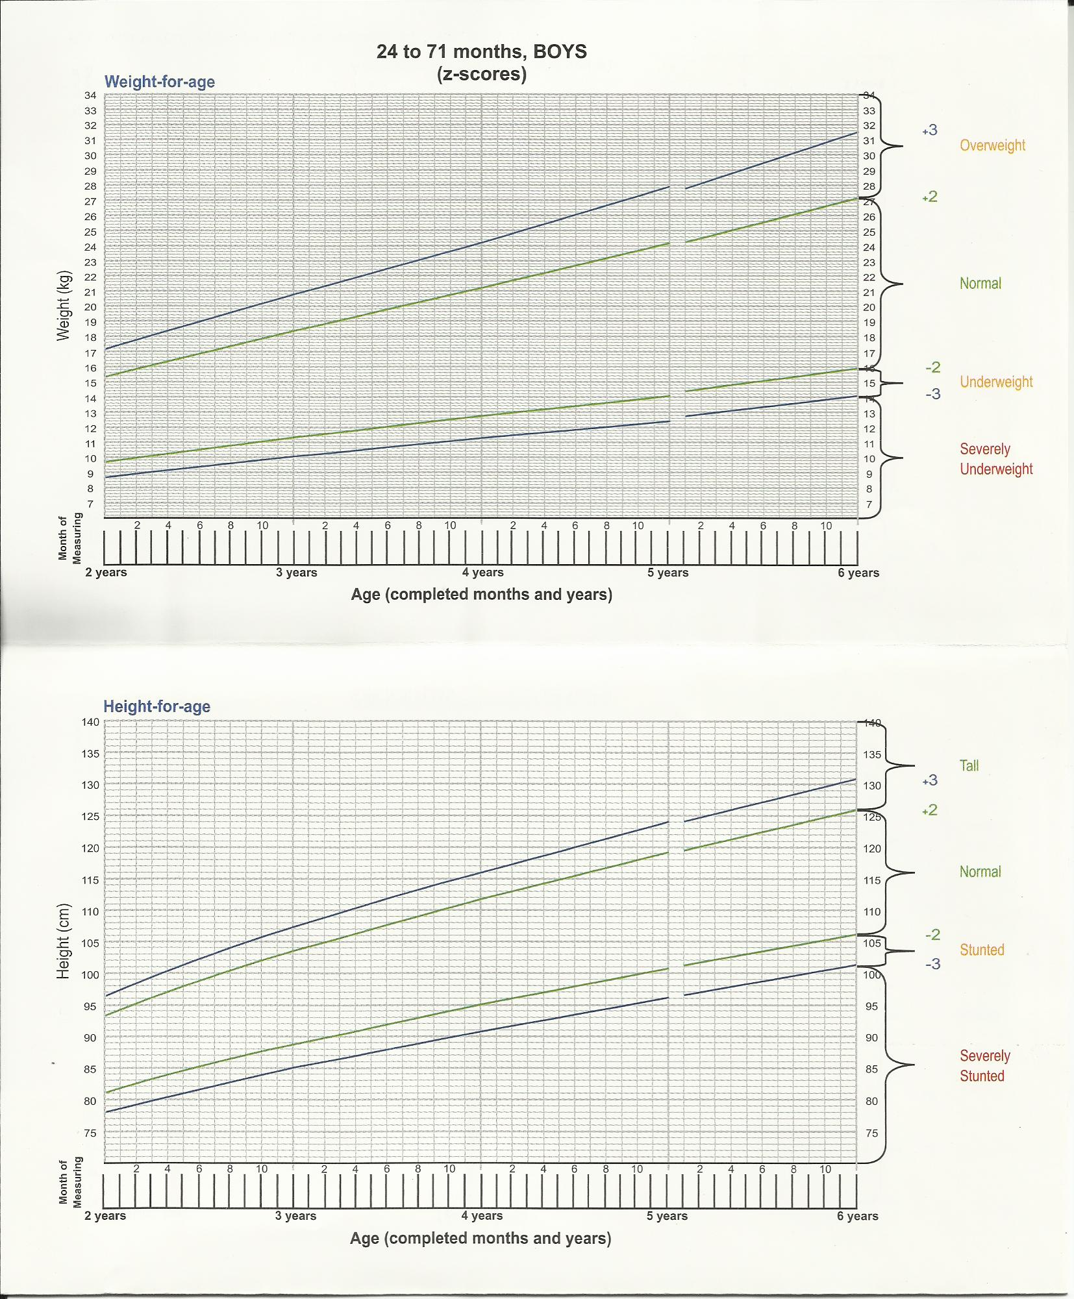

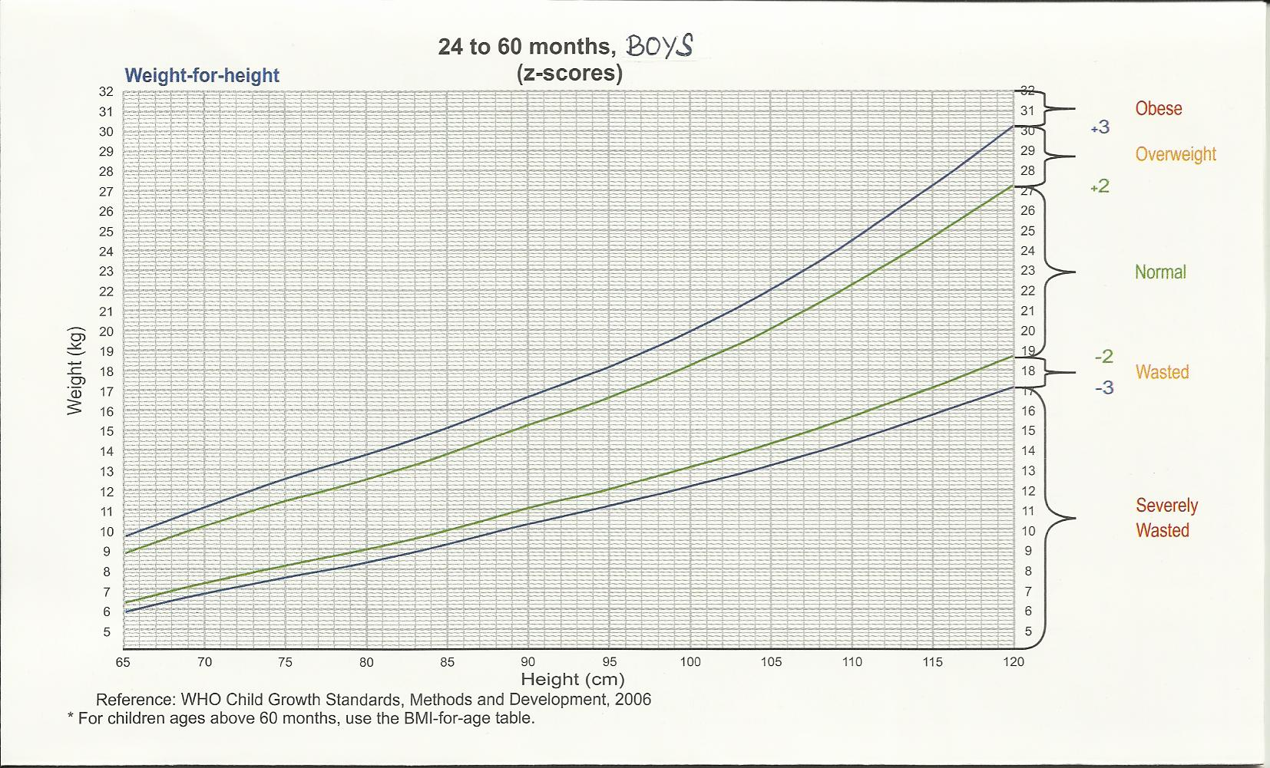

E. ROLE OF BHWS IN THE GROWTH MONITORING AND PROMOTION OF A CHILD
1. Conduct monthly weighing (with reports) especially during immunization days;
2. Refer children with negative growth curves, and malnourished infants/children, to health center;
3. Home visits to children showing two months of flat or negative growth:
4. Observe the household
    - Sanitation problems?
    - Food insecurity/financial stress?
    - Safety/security problems?
5. Discuss child feeding
6. Reinforce suggestions given at weighing session;
7. Home visits to children referred to health centre:
    - Visit during second week after referral.
    - If referred for illness
8. Ensure that mother has taken child to provider;

9. Ensure that mother is following instructions of provider (purchase medicine, administration of medicine);
10. Ensure that mother is following guidelines for feeding of sick child;
11. Organize and conduct community discussions-
- Every month
- BNS will assist
- Record community decisions on ways to improve progress
- Follow up on community decisions from previous community discussions

“When we serve them (people of God) with joy. We honor and serve our God, and in Him do we find our true happiness, the peace that this world cannot bring.”
-MAT. 20:17

GOD BLESS US ALL
WITH OUR NEW MISSION!!!

