

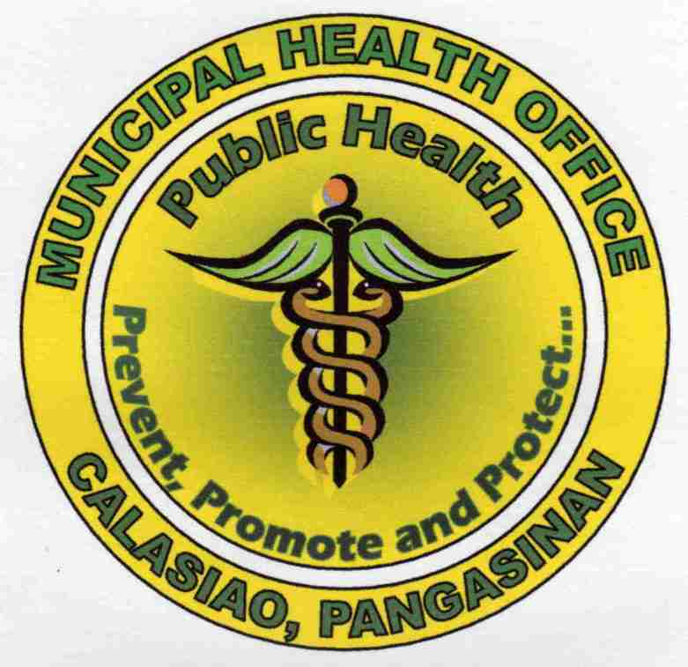

Republic of the Philippines

Province of Pangasinan

# MUNICIPALITY OF CALASIAO

**MUNICIPAL HEALTH OFFICE**

**SECURING HEALTH CERTIFICATE**

**CLIENT**

**ADMITTING SECTION**

* Get client’s vital signs
* Physical Examination

No findings of medical illness

With findings of medical illness

Treatment

Payment of prescribed fees including laboratory fees

After treatment period, client is re-evaluated

After treatment period, client is re-evaluated

With abnormal laboratory findings

No abnormal laboratory findings

**LABORATORY SECTION**

* Submit specimen for stool and sputum examination

To be renewed every 6 months

Issuance of

Health Certificate (White Card)

**SANITATION SECTION**

* Recording

Treatment as per NTP-DOTS Protocol

Supervised Deworming (single dose)

Positive for sputum examination

Positive for intestinal parasitism