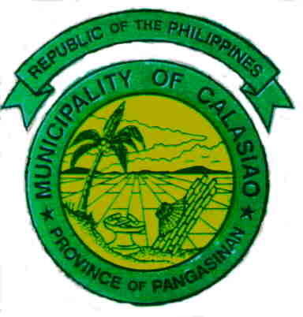
Republic of the Philippines
Province of Pangasinan

MUNICIPALITY OF CALASIAO

MUNICIPAL HEALTH OFFICE

APPLICATION AND ISSUANCE OF SANITARY PERMIT
FOR FOOD & NON-FOOD ESTABLISHMENTS

Application of Business Permit

Payment of prescribed Sanitary Inspection Fee

Non - Food Establishment
a) Sanitary Inspection Report *
b) No Health Certificate needed except for establishments identified in the Sanitation Code of the Philippines
- Massage Attendants
- Barber Shops / Beauty Parlors
- Guest Relations Officer in Night establishments

Food Establishment
a) Sanitary Inspection Report *
b) Secure Health Certificate for all Food Handlers **
- payment of Appropriate fees
- laboratory examination
- physical examination by physician on duty
- Issuance of Health Certificates

Compliance
Non Compliance

Issuance of Sanitary
Permit to Operate
(valid till December 31
of application year) ***
Within 3 working days
Corrective Measures

Re-application

Recording of issuance of Sanitary Permit

* Sanitary Inspection report forms depends on type of food establishment
** White Card to be renewed every 6 months
***Can be revoked for non-compliance after due process

