Republic of the Philippines
Province of Pangasinan

MUNICIPALITY OF CALASIAO

MUNICIPAL HEALTH OFFICE

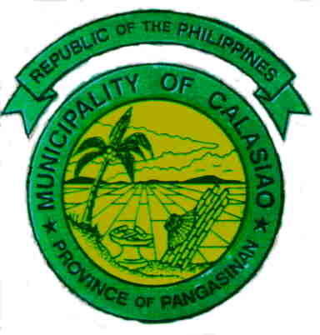

APPLICATION AND ISSUANCE OF SANITARY PERMIT
FOR WATER REFILLING STATION
Application of Business Permit

Payment of prescribed Sanitary Inspection Fee

1. Sanitary Inspection Report
2. Other Requirements
NEW:
Operational Permit
- Application for Drinking Water Site Clearance
- Sanitary Survey of Water Source
- Certificate of Connection
- Plans and Specifications
- Drinking Water Site Clearance
- Certificate of Potability
- Physiochemical Test Results
- Bacteriological Test Results
40 Hour Certification Course
Health Certificates
RENEWAL:
Physiochemical Test Results
Bacteriological Test Results
Health Certificate (White Card)

Compliance
Non Compliance

Within 3 working days
Issuance of Sanitary
Permit to Operate
(valid till December 31
of application year) *
Corrective Measures

Re-application

Recording of issuance of Sanitary Permit

*Can be revoked for non-compliance after due process

