Republic of the Philippines

Province of Pangasinan

# MUNICIPALITY OF CALASIAO

**MUNICIPAL HEALTH OFFICE**



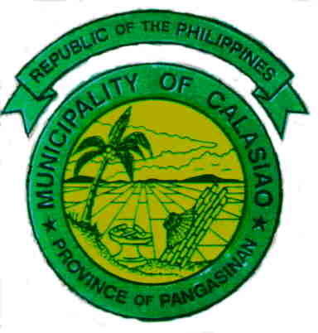

**SECURING MEDICAL CERTIFICATE**

**CLIENT**

**ADMITTING SECTION**

* Get Client’s vital signs
* Physical Examination

No findings of medical illness

With findings of medical illness

Treatment

Payment of prescribed fee

Issuance of

Medical Certificate

(White Card)

After treatment period, client is re-evaluated