Republic of the Philippines

Province of Pangasinan

# MUNICIPALITY OF CALASIAO

**MUNICIPAL HEALTH OFFICE**

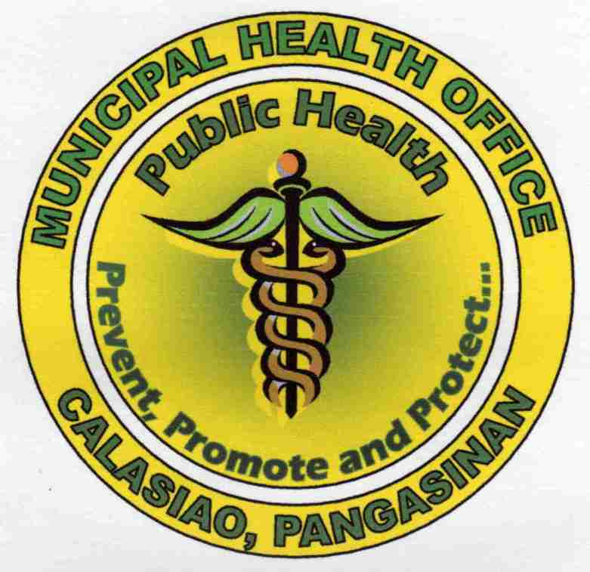

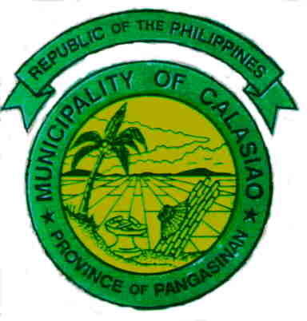

**MEDICO-LEGAL SERVICES**

Report to the local PNP for investigation and recording

**Physical Injury**

**Post Mortem**

Report to the local PNP for investigation and recording preferably within 24 hours after the incident

Letter Request from the local PNP or other law enforcement/investigation agencies

Letter Request from the local PNP/ Women and Child Protection Unit (WCPU)

* Victims who are minors are to be accompanied by guardian and/or MSWD personnel
* Victims of sexual abuse are referred to the R1MC/PPH Women and Child Protection Unit (WCPU)

Conduct post-mortem examination by the MHO/RHP

Conduct medico-legal examination by the MHO/RHP

Issuance of Post Mortem Reportto local PNP or authorized agencies

Issuance of Medico Legal Certificate to authorized persons (local PNP, guardian, social worker)